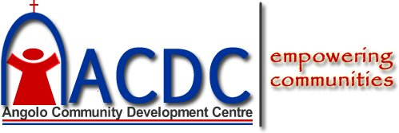 | 
Note for Logo: - Replace the Logo above – Keep the writings and the outline above except the logo. Use the female figure to replace the child figure in red. Also replace arch and the cross with the dorm. | PHYSICAL & POSTAL CONTACT ADDRESS  Pamela Amoiya Obonde  Programs Coordinator, ACDC Secretariat  Baghwanji Building, 2nd FL Biashara Street  P.O. Box 15285-00100,Nairobi-KENYA
WHO WE ARE  ACDC is registered in Kenya as a Not-For-Profit development facilitator whose overall goal is to create access to socio-economic opportunities towards empowering Women, Children and the Youth.  ACDC works through a variety of strategies which includes mobilization of women and youth into self-governing community based groups (SHG/CBOs).  Children, girl child protection and participation are advocated as a cross-cutting issue by partnering with the communities and socio-educational institutions such as families, schools, faith based and CBOs.  OUR LONGTERM STRATEGIES  Our long-term strategies include Mobilization, Training, Advocacy, Research, Networking, Relief and Support  OUR GOAL  ACDC’s overall goal is to create and increase access to socio-economic and educational opportunities for marginalized children, youth, women and their communities. | TELEPHONE & EMAIL ADDRESS  Tel. +254-020-2 217 059/Mobile +254 722 352 425  acdcwdp@gmail.com / info@acdc-kenya.org
WEB Site:
www.acdc-kenya.org
PROJECTS FIELD OFFICES
ACDC-Saikeri Women Enterprise Centre in Kajiado County
ACDC-Ang’olo Women Enterprise Centre in Siaya County
ACDC-Peace Leadership Education Centre in Kasarani Nairobi County
THE BELGIUM - ANTWERPEN CHAPTER
Patroba Yator –WZC Bilzenhof
Lange BeeldenKensstraat 48-50
2060 Antwerpen-BELGIUM.
Email:- bel.angolo2013@gmail.com
OUR VISION
We envision a socially and economically empowered society free of poverty and gender disparities.
OUR MISSION
To promote, advocate and foster socio-economic transformation of women, children, youth and their communities towards poverty reduction through a sustainable participatory approach.
OUR CORE VALUES
We do everything: - To the glory of God; In total surrender and obedience to our Creator; For the greater value in “WE” than “I”; With Integrity, Transparency and Accountability. In recognition that Teamwork, Collaboration, Network and Partnership define the relationships among ourselves, with organizations and the communities that we serve.

